**Helping material for understanding**

**Project Report on Gender and Age Detection Using Deep Learning**

**Introduction**

The "Gender and Age Detection" project employs Deep Learning to classify gender and age from facial images using pre-trained models by Tal Hassner and Gil Levi. It categorizes gender as 'Male' or 'Female' and age into predefined ranges, acknowledging the inherent variability in facial features. This project showcases the fusion of computer vision and machine learning, offering practical insights into real-world applications.

**Dataset**

The Python project utilized the Adience dataset, comprising over 26,000 facial photos of approximately 2,000 individuals. This dataset encompasses diverse real-world conditions like lighting and poses. Trained on Adience, the project's models accurately predict gender and age from facial images.

**Technical FrameWork**

**OpenCv**: The purpose of OpenCV is for image processing and computer vision tasks within the Python project.

**argparse** The purpose of argparse is to handle command-line arguments passed to the Python script, making it easier to parse and process user inputs.

**Implementation Steps:**

Face Detection: Use pre-trained TensorFlow model to identify faces.

Age and Gender Prediction: Employ separate models for gender and age estimation, trained on Adience dataset.

Integration: Combine components into user-friendly application for image or video input.

**Algorithm**

Algorithm: Utilize Convolutional Neural Network (CNN).

Training: Train CNN on Adience dataset.

Purpose: Recognize patterns for age and gender classification.

**CNN Architecture**

**CNN Basics:** CNNs are specialized neural networks used in Computer Vision tasks within AI, designed to interpret visual information like images.

**Key Components:**

- Input Layer: Receives raw data, often pixels from images.

- Hidden Layers: Consist of Convolutional, Pooling, and Fully Connected layers.

- Output Layer: Produces final predictions, often using softmax for classification tasks.

**Functionality:**

- Convolutional Layers: Detect important features like edges in images.

- Pooling Layers: Simplify information by reducing dimensionality.

- Fully Connected Layers: Make final decisions based on extracted features.

**Learning Process:**

- CNNs use feedforward to pass data through layers and adjust weights through backpropagation to minimize errors.

**Automated Feature Extraction:**

- CNNs automatically find important patterns in data, eliminating the need for manual feature selection.

**Importance:**

- CNNs are crucial for accurate image and video analysis in modern AI applications due to their ability to handle complex visual tasks effectively.

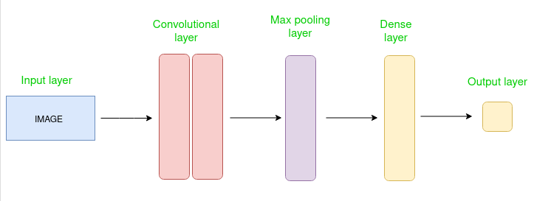

**Application and usage of gender and age detection from facial images**

**Security and Surveillance:** Implementing facial recognition for access control in secure areas or for monitoring individuals in public spaces.

**Marketing and Advertising:** Tailoring advertisements and marketing campaigns based on demographic information obtained from facial analysis.

**Healthcare:** Assessing patient demographics for personalized healthcare services or demographic analysis in medical research.

**Entertainment:** Providing personalized content recommendations or interactive experiences based on demographic characteristics.

**Retail:** Analyzing customer demographics for targeted product recommendations and optimizing store layouts.

Overall, the application of gender and age detection from facial images can revolutionize various industries, offering personalized experiences and optimizing decision-making processes.

**Conclusion**

This project showcases the power of deep learning in computer vision, accurately classifying gender and age from facial features. Despite challenges, it achieves high accuracy due to robust CNN models and the Adience dataset. Future improvements could focus on dataset expansion, model refinement, and real-time optimization, offering a practical tool for biometric analysis and inspiring further AI research.